St. George’s Anglican Church
83 Church Street, St. Catharines ON L7R 3C7
Pre Authorized Giving Invitation

You can support your parish with a monthly contribution withdrawn from your bank account.
There’s no fee, you can cancel at any time and St. George’s will issue your annual tax receipt.
Please fill in this form and return it to Jim Jenter with your void cheque.

Parishioner Name:

Address:

City:_____________________________________ Postal Code:________________________________

Phone: __________________________________ Email:_____________________________________

Attach a void cheque here for the account to use for your donation.
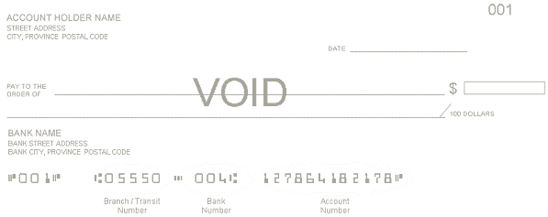

Payment can be taken any day of the month. Please indicate the date you prefer.

I/we hereby authorize the “Diocese of Niagara” to debit my/our bank account each month on the
of the month in the amount of $ for SCSGE
(date(s)) (St. George’s Parish Code)

NEW □ INCREASE □ DECREASE □ CHANGE BANKING INFORMATION □

This authorization is to remain in effect until The Diocese of Niagara has received written notice from me/us of its change or termination. Please note that we must receive the change or termination by the 18th of the month in order for it to take effect for the following month. In an emergency the PAD can be recalled or stop payment with a 24 hour notice. To obtain a sample cancellation form, or for more information on my right to cancel a PAD Agreement, I may contact my financial institution or visit www.cdnpay.ca.

I have certain recourse rights if any debit does not comply with this agreement. For example, I have the right to receive reimbursement for any debit that is not authorized or is not consistent with this PAD Agreement. To obtain more information on my recourse rights, I may contact my financial institution or visit www.cdnpay.ca.

Date:
Signature:

Return to Jim Jenter, St. George’s Anglican Church, 83 Church Street,St. Catharines, Ontario L2R 3C7 or email to treasurer@stgeorgesanglican.ca

